**Project Design Phase-II**

**Data Flow Diagram & User Stories**

|  |  |
| --- | --- |
| Date | 12 May 2023 |
| Team ID | NM2023TMID22230 |
| Project Name | Project - SQUID: Street Quality Identification |

**Data Flow Diagram:**



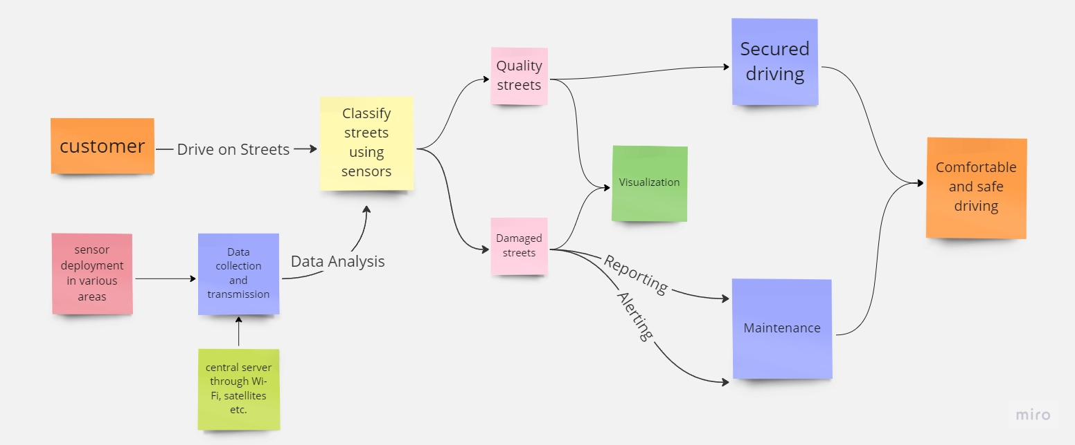

**User Stories:**

| **User Type** | **Functional Requirement (Epic)** | **User Story Number** | **User Story / Task** | **Acceptance criteria** | **Priority** | **Team Member** |
| --- | --- | --- | --- | --- | --- | --- |
| City Residents | The mobile app should allow users to submit pictures and descriptions of the street quality issue, along with their location data. | USN-1 | As a city resident, I want to be able to report poor street quality through a mobile app, so that the city can efficiently prioritize repairs and maintenance. | The app should be easy to use and intuitive, and should provide confirmation that the report has been submitted successfully. | High | Shruthi B K |
| City Planners | The system should store all street quality data in a central database that can be easily accessed and analyzed. | USN-2 | As a city planner, I want to be able to access historical street quality data, so that I can make informed decisions about future infrastructure investments. | The database should be easy to navigate and search, and should provide useful data visualizations. | Medium | Shruthi B K |
| Business owner | Map of parking spots near businesses. | USN-3 | As a business owner, I want to be able to view a map of parking spots near my business, so that my customers can find parking more easily. | Map should be easy to navigate and show locations of parking spots near businesses. | Low | Shruthi B K |
| City Government | The IoT sensors should be able to detect and report on a range of street quality issues, such as cracks, and uneven surfaces. | USN-4 | As a city government, I want to be able to track and monitor the condition of all streets in the city, so that we can allocate resources for repairs and maintenance. | The sensors should be able to accurately detect street quality issues, and should be able to report this data back to a central dashboard. | High | Vinitha K |
| Delivery driver | Map of loading zones and parking spots. | USN-5 | As a delivery driver, I want to be able to view a map of loading zones and parking spots, so that I can make deliveries more efficiently. | Map should be easy to navigate and show locations of loading zones and parking spots. | Medium | Vinitha K |
| Tourist | Map of popular attractions and landmarks | USN-6 | As a tourist, I want to be able to view a map of popular attractions and landmarks, so that I can explore the city more easily. | Map should be easy to navigate and show locations of popular attractions and landmarks. | Low | Vinitha K |
| Pedestrian | Mobile app for reporting street quality issues | USN-7 | As a pedestrian, I want to be able to report potholes and other street quality issues using a mobile app, so that the city can address them in a timely manner. | App should allow users to easily report street quality issues and send a notification to the city government. | High | Pavithra B |
| Public transit user | Map of bus and train routes | USN-8 | As a public transit user, I want to be able to view a map of bus and train routes, so that I can plan my commute more easily. | Map should be easy to navigate and show routes for different bus and train lines. | Medium | Pavithra B |
| Cyclist | Map of bike-friendly streets | USN-9 | As a cyclist, I want to be able to view a map of bike-friendly streets, so that I can plan my route more easily and avoid unsafe roads. | Map should show bike lanes, routes, and trails, and highlight unsafe streets. | Low | Pavithra B |